# Water Flow Test

Torito Liquid Propulsion Project

Contents

Piping and Instrumentation Diagram Considerations 1

1-1 Tubing Diameter and Working Pressures 2

2-1 Tubing Manufacturing and Installations 2

2.1.1 Design of Tube Fittings 3

2.1.2 Desing of Flanged Joints 4

2.1.3 Engineering Analysis of Bending 4

3-1 Control and Condition-Monitoring Systems 6

4-1 Pipe Flow Analysis and Pressure Differential Calculations 7

References 9

## 1-1 Engine Contours

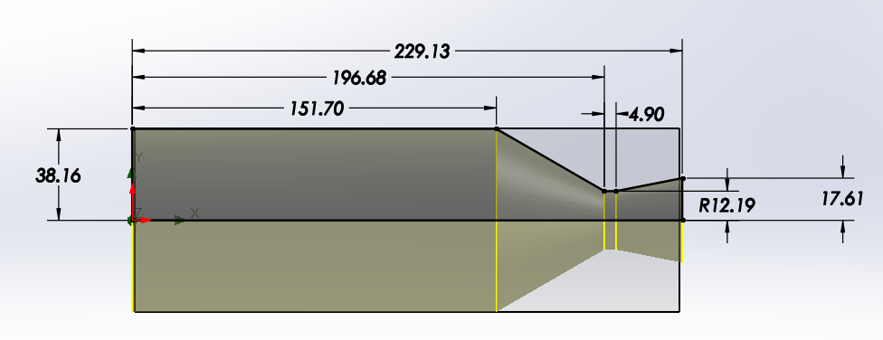

|  |  |
| --- | --- |
|  | (mm) |
| Combustion Chamber (Diameter) | 38.16 |
| Combustion Chamber (Length) | 151.70 |
| Nozzle Throat (Length) | 4.90 |
| Nozzle Throat (Radius) | 12.19 |
| Nozzle Exit (Radius) | 17.61 |

## 2-1 Parameters

### 2.1.1 Characteristic Length L*

L* = Characteristic Length (m)

Vc = Volume of the Combustion Chamber ($m^{3})$

At = Area of the Throat $(m^{2})$

This value, L *, is generally used for determining the combustion chamber volume rather than the stay time. Compare charts and compare stay time to literature data. The L* is found using past experiments/experience using a similar engine/Propellant combination. [1]

## 2-1 Design Equations

### 2.1.1 Goal

**The Ultimate Goa**

Given the cross sectional area of the nozzle throat

[**https://www.grc.nasa.gov/www/k-12/rocket/nozzle.html**](https://www.grc.nasa.gov/www/k-12/rocket/nozzle.html)

**https://ntrs.nasa.gov/api/citations/19710019929/downloads/19710019929.pdf**

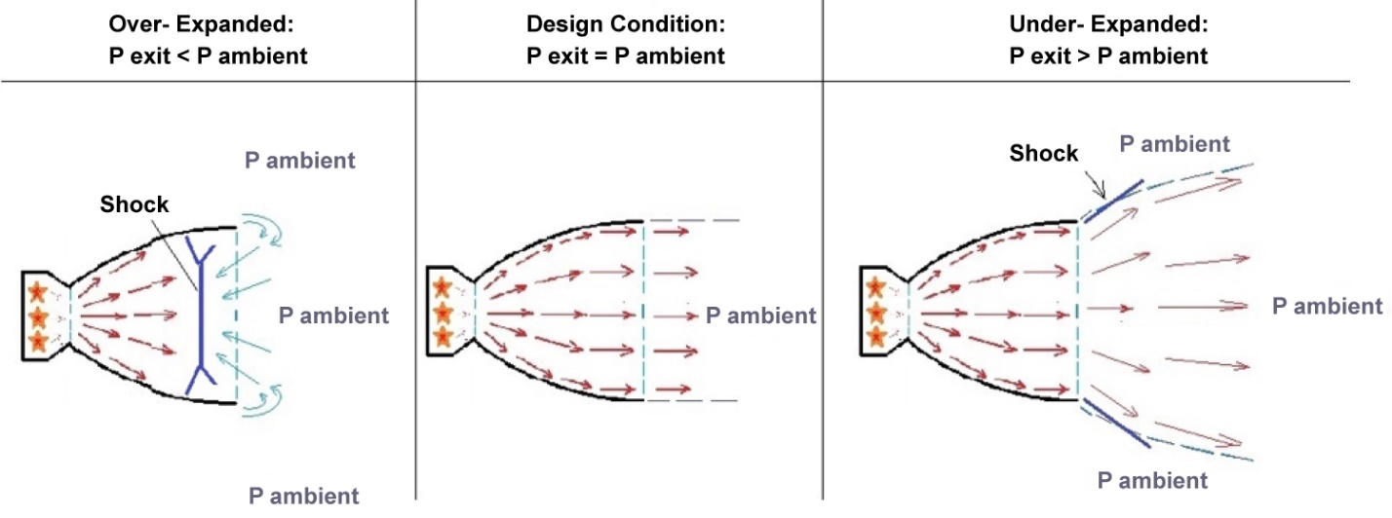

**https://www.engineeringtoolbox.com/standard-atmosphere-d_604.html**

# Udemy Course Summary

## Introduction: The Ideal Rocket

* Isentropic
  + Both adiabatic and reversible
  + The work transfers of the system are frictionless
  + No transfer of heat or matter
* 11 Assumptions
  + The chemical reaction products is homogeneous
  + All species of working fluid are gaseous. Any condensed phases (liquid or solid) add a negligible amount to the total mass
  + Working substance obeys perfect gas law
  + Adiabatic: No heat transfer across the rocket walls
  + No appreciable friction + all boundary layer effects are negelected
  + No shock waves or dicotinuities in nozzle flow
  + Propellant flow is stead and constant
    - Expansion of working fluid is uniform and steady (without vibration0
    - Transient effects (starup and shutdown) are of very short duration and may be neglected
  + All exhaust gases leaving the rocket have an axially directed velocity
  + Gas velocity, pressure, temperature, and density are all uniform across ay section normal to the nozzle axis
  + Chemical Equilibrium is established within the rocket chamber + gas composition does not change in the nozzle (frozen flow)
  + Stored propellants are at room temperature

## Mass Flow Rate in Isentropic Flow

## Deriving the Flow Equation

# Bibliography

|  |  |
| --- | --- |
| [1] | C. S. Austin Sennott, "How to Design Pressure Vessels, Propellant Tanks," Half Cat Rocketry Technical Resources, Austin Sennott. |
| [2] | D. K. H. a. D. H. H. liang, "Design of Liquid Propellant Rocket Engines," NASA, 1967. [Online]. Available: https://ntrs.nasa.gov/api/citations/19710019929/downloads/19710019929.pdf. |
| [3] | "Understanding Performance Fittings – Straight and AN Threads vs. Tapered Thread," SpeedNews, [Online]. Available: https://nasaspeed.news/tech/engine/understanding-performance-fittings-straight-and-an-threads-vs-tapered-thread/. |